Inventory Count
- Create inventory count report
This section displays how to upload the warehouse inventory count and to print the specified list.

- Select Inventory Counting in the Inventory module.
Inventory Inventory transactions Inventory Counting transactions Inventory Counting
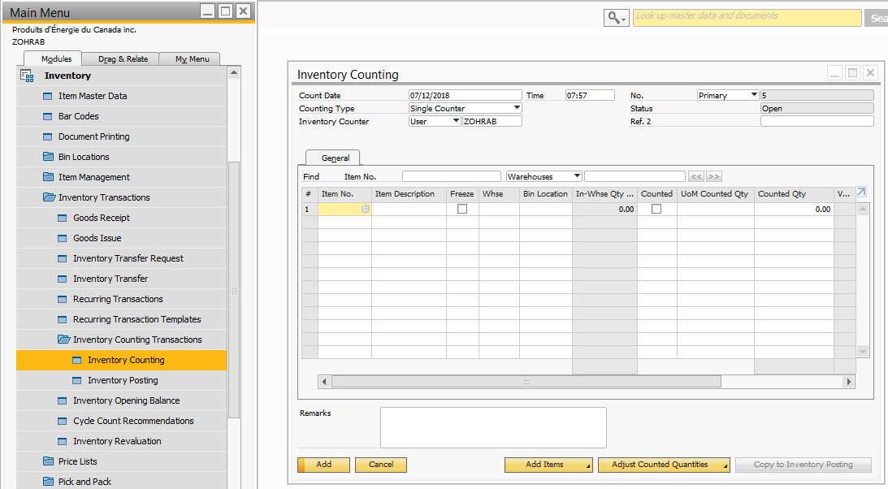

- Upload the Items list.
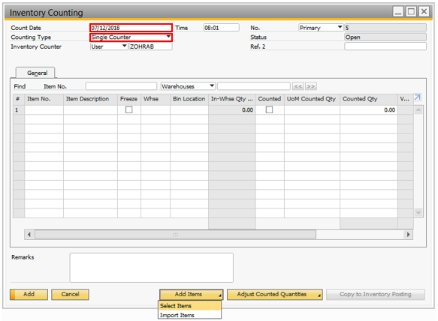
- Set the current date in the count date field.

- Always use Single Counter for counting type.

- Select “Select Items”.

- Select warehouse to pull the items list.
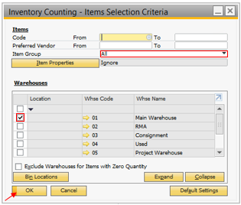
- Select “All” for the Item group.

- Choose the warehouse by pressing on the checkbox field.

- Press “OK” to continue.

Executing report
- It takes a few seconds to upload the list of items.

- Once the list has been imported, you are now ready to print the report.
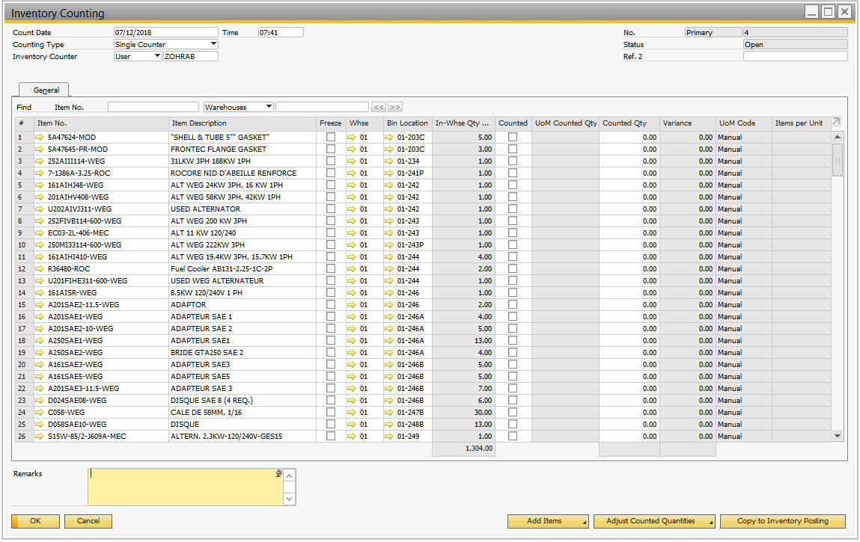
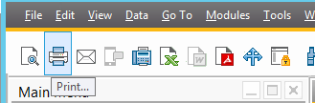
- Select the “Print button” on the toolbar.

- Adjustments
This section displays how to make adjustments in order to correct the inventory count for the warehouse selected.

- Adjustments need to be changed in the Counted Qty column

- Search for the item that needs to be corrected by scrolling through the list.

- Select the Counted Qty cell for that item.

- Manually input the new value.

- Select “Copy to Inventory Posting” to update the inventory count in the system.


- Inventory posting table will now be displayed.
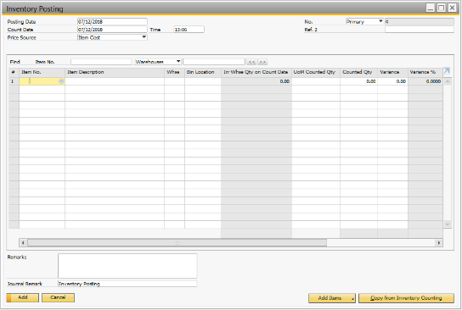

- Select the Left Arrow to view last record that was copied from the Inventory Count.
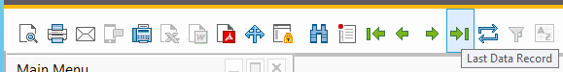

- Select “Add” to remove a Serial number from the Inventory count.
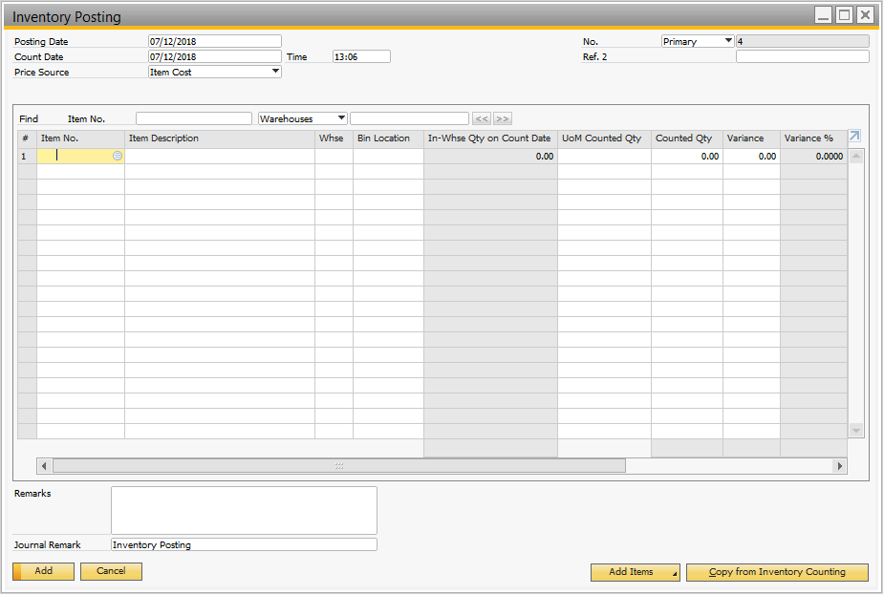

- To remove a Serial number from the list, you must select the item from the left table and select the arrow pointing towards the right table.
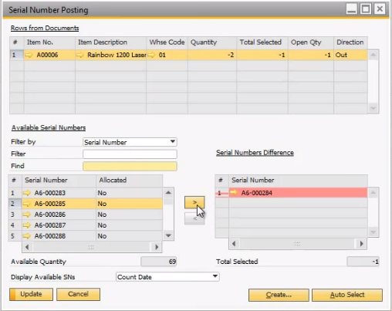

- Update your information by selecting “Update”.


- You can now validate your new inventory count
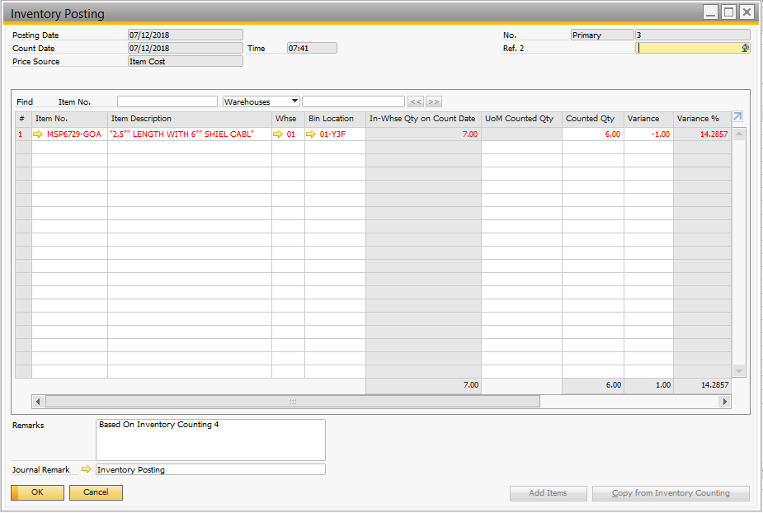

- Select “OK” to close.


